REQUIREMENTS OF THE PROJECT:

There were a lot of components used for the final project. Let's look at them one by one.

ARDUINO PRO MINI

The**Arduino Pro Mini** is a microcontroller board based on the ATmega328.   
It has 14 digital input/output pins (of which 6 can be used as PWM outputs), 6 analog inputs, an on-board resonator, a reset button, and holes for mounting pin headers. A six pin header can be connected to an FTDI cable or Sparkfun breakout board to provide USB power and communication to the board.  
The Arduino Pro Mini is intended for semi-permanent installation in objects or exhibitions. The board comes without pre-mounted headers, allowing the use of various types of connectors or direct soldering of wires. The pin layout is compatible with the Arduino Mini.   
There are two version of the Pro Mini. One runs at 3.3V and 8 MHz, the other at 5V and 16 MHz.   
The Arduino Pro Mini was designed and is manufactured by SparkFun Electronics.

SPECIFICATIONS:

|  |  |
| --- | --- |
| **Arduino Pro Mini DETAILS** | |
| Microcontroller | ATmega168 |
| Operating Voltage | 3.3V or 5V |
| Input Voltage | 3.35 -12 V (3.3V model) or 5 - 12 V (5V model) |
| Digital I/O Pins | 14 (of which 6 provide PWM output) |
| Analog Input Pins | 8 |
| DC Current per I/O Pin | 40 mA |
| Flash Memory | 16 KB (of which 2 KB used by bootloader) |
| SRAM | 1 KB |
| EEPROM | 512 bytes |
| Clock Speed | 8 MHz (3.3V model) or 16 MHz (5V model) |

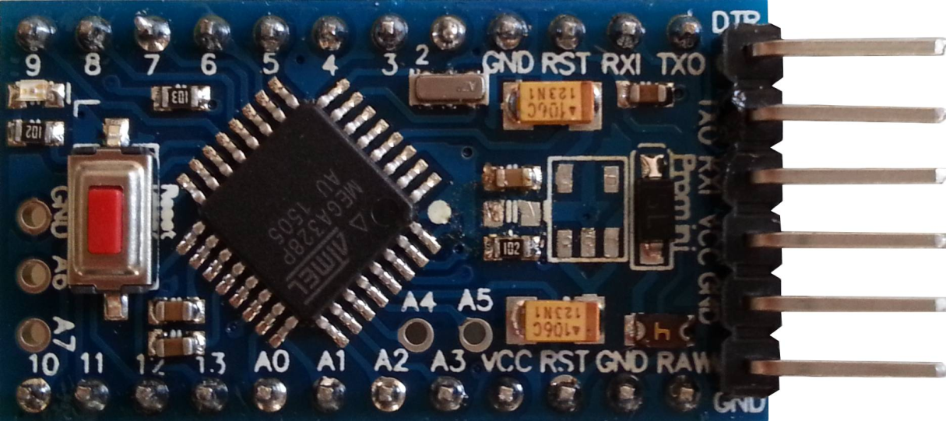

END STOP SWITCH

End stop switches are low friction mechanical switches which can easily be turned on with a small amount of force. In the project, this force is coming by the head of the rider. The mechanical endstop uses a lever switch to detect when it is activated. The switch is wired up so that when activated, it pulls the signal to LOW.

REASONS TO USE MECHANICAL ENDSTOPS

* Switches are the cheapest endstops in most cases.
* No need for opto pcb.
* Simple switches can be used on x and y axis.
* You could even make your own contact switch from a few pieces of metal.

LIMITATIONS:

* Switches have a limited number of on/off cycles. However, most purpose built micro-switches are rated for well over 1,000,000 cycles and will last years.
* [Needs new way to mount switch](http://reprap.org/wiki/Mechanical_Endstop#Switch_mounting), which will depend on the switch type.

PINS OF AN ENDSTOP SWITCH

|  |  |
| --- | --- |
| **Pin** | **Function** |
| +5 | This is the pin to supply +5 volts on. |
| S | This is the signal pin. It will output high (+5) if it is triggered, or low (0v) if it is clear |
| G | This is the ground pin. |

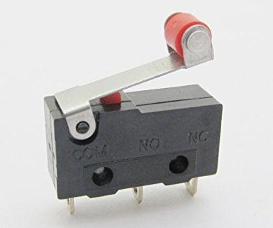

TRANSMITTER AND RECIEVER:

The transmitter and receiver used is a scaled down version of the RF315 transmitter receiver module.

The RF module, as the name suggests, operates at Radio Frequency. The corresponding frequency range varies between 30 kHz & 300 GHz. In this RF system, the digital data is represented as variations in the amplitude of carrier wave. This kind of modulation is known as Amplitude Shift Keying (ASK).

Transmission through RF is better than IR (infrared) because of many reasons. Firstly, signals through RF can travel through larger distances making it suitable for long range applications. Also, while IR mostly operates in line-of-sight mode, RF signals can travel even when there is an obstruction between transmitter & receiver. Next, RF transmission is more strong and reliable than IR transmission. RF communication uses a specific frequency unlike IR signals which are affected by other IR emitting sources.

This **RF module** comprises of an **RF Transmitter** and an **RF Receiver**. The transmitter/receiver (Tx/Rx) pair operates at a frequency of **434 MHz**. An RF transmitter receives serial data and transmits it wirelessly through RF through its antenna connected at pin4. The transmission occurs at the rate of 1Kbps - 10Kbps.The transmitted data is received by an RF receiver operating at the same frequency as that of the transmitter.

The RF module is often used alongwith a pair of encoder/decoder. The encoder is used for encoding parallel data for transmission feed while reception is decoded by a decoder. [HT12E](http://www.engineersgarage.com/content/ht12e)-[HT12D](http://www.engineersgarage.com/content/ht12d), HT640-HT648, etc. are some commonly used encoder/decoder pair ICs.

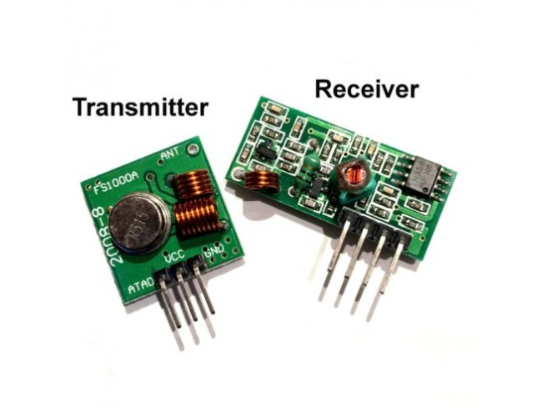

### Pin Diagram:

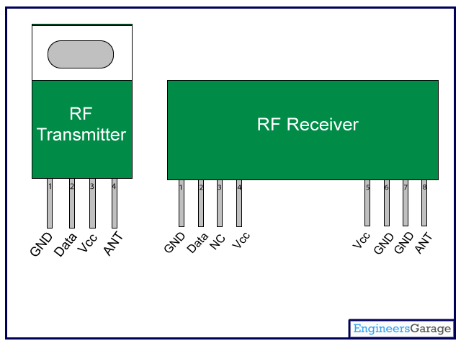

### Pin Description:

**RF Transmitter**

|  |  |  |
| --- | --- | --- |
| **Pin No** | **Function** | **Name** |
| 1 | Ground (0V) | Ground |
| 2 | Serial data input pin | Data |
| 3 | Supply voltage; 5V | Vcc |
| 4 | Antenna output pin | ANT |

**RF Receiver**

|  |  |  |
| --- | --- | --- |
| **Pin No** | **Function** | **Name** |
| 1 | Ground (0V) | Ground |
| 2 | Serial data output pin | Data |
| 3 | Linear output pin; not connected | NC |
| 4 | Supply voltage; 5V | Vcc |
| 5 | Supply voltage; 5V | Vcc |
| 6 | Ground (0V) | Ground |
| 7 | Ground (0V) | Ground |
| 8 | Antenna input pin | ANT |

RELAY

A **relay** is an [electrically](https://en.wikipedia.org/wiki/Electric) operated [switch](https://en.wikipedia.org/wiki/Switch). Many relays use an [electromagnet](https://en.wikipedia.org/wiki/Electromagnet) to mechanically operate a switch, but other operating principles are also used, such as [solid-state relays](https://en.wikipedia.org/wiki/Solid-state_relay). Relays are used where it is necessary to control a circuit by a separate low-power signal, or where several circuits must be controlled by one signal. The first relays were used in long distance [telegraph](https://en.wikipedia.org/wiki/Electrical_telegraph) circuits as amplifiers: they repeated the signal coming in from one circuit and re-transmitted it on another circuit. Relays were used extensively in telephone exchanges and early computers to perform logical operations.

A type of relay that can handle the high power required to directly control an electric motor or other loads is called a [contactor](https://en.wikipedia.org/wiki/Contactor" \o "Contactor). [Solid-state relays](https://en.wikipedia.org/wiki/Solid-state_relay)control power circuits with no [moving parts](https://en.wikipedia.org/wiki/Moving_parts), instead using a semiconductor device to perform switching. Relays with calibrated operating characteristics and sometimes multiple operating coils are used to protect electrical circuits from overload or faults; in modern electric power systems these functions are performed by digital instruments still called "[protective relays](https://en.wikipedia.org/wiki/Protective_relay)"

A simple electromagnetic relay consists of a coil of wire wrapped around a [soft iron core](https://en.wikipedia.org/wiki/Magnetic_core) (a solenoid), an iron yoke which provides a low [reluctance](https://en.wikipedia.org/wiki/Magnetic_reluctance) path for magnetic flux, a movable iron [armature](https://en.wikipedia.org/wiki/Armature_(electrical_engineering)), and one or more sets of contacts (there are two contacts in the relay pictured). The armature is hinged to the yoke and mechanically linked to one or more sets of moving contacts. The armature is held in place by a [spring](https://en.wikipedia.org/wiki/Spring_(device)) so that when the relay is de-energized there is an air gap in the magnetic circuit. In this condition, one of the two sets of contacts in the relay pictured is closed, and the other set is open.

This relay is connected to the bike.

